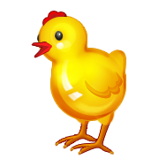
Chick Observation Journal

Date: ___________________________________
Today I saw the chicks: __________________________________________________________________________________________________---------------------------------------------------------------------------------------------------------------------------------------------------__________________________________________________________________________________________________
Why I think the chicks were doing this was: __________________________________________________________________________________________________---------------------------------------------------------------------------------------------------------------------------------------------------__________________________________________________________________________________________________

Here is what the chicks look like today:

